Just for Parrots thanks you for allowing us to add a wonderful addition to your family!

This is a new and exciting time. Your bird will be able to bring happiness for a long time ahead.

This packet has some information to better your life and the life of your bird.

We encourage you to learn more about your bird and what they may enjoy.

Please note this is broad information and each bird is different. We hope for you to do more research on the foods, woods and other things for a fulfilling and safe life with your bird.

Just for Parrots

1943 S. Glenstone Ave., Suite C

Springfield, MO 65804

(417)576-2704

“15 MINUTE RULE”

For those of our customers who are taking home a just weaned baby, please follow the “15 Minute Rule”.

The “15 Minute Rule” means that once you have your new baby bird home you can play with him/her for 15 minutes and then put them back in their cage for 2 hours before taking them out of their cage again, and then repeat the rule. This allows them to have sufficient time to eat, drink and sleep. If this rule is not followed it could lead to them not eating and drinking a sufficient amount, which could cause illness or death to your bird.

This rule should be followed for the first two (2) weeks after taking them home.

CHANGE AND WASH YOUR BIRD’S WATER BOWL EVERYDAY!

Birds bathe, play and dunk their food in their water which creates bacteria. If you do not change the water everyday it could lead to illness or death to your bird.

**Safe Fruits and Vegetables**

**Please be sure to remove all seeds and pits from fruit and vegetables!**

|  |  |
| --- | --- |
| Fruits | Vegetables |
| Apples | Artichoke |
| Apricot | Beans (cooked) |
| Banana | Bell Peppers |
|  | Bok Choi |
| Blackberry | Broccoli |
| Blueberry | Brussel Sprouts |
| Cantaloupe | Carrot |
| Cherry | Cauliflower |
| Cranberry | Celery ( in small pieces) |
| Dried Dates | Corn |
| Grape | Cucumber |
| Grapefruit | Dandelions |
| Guava | Green Beans |
| Honeydew | Hot Peppers |
| Kiwi | Kale |
| Lemon | Parsnips |
| Lime | Peas |
| Mango | Potato (cooked) |
| Nectarine | Pumpkin and Pumpkin Seeds |
| Orange | Okra |
| Papaya | Radish |
| Passionfruit | Snow Peas |
| Peach | Spinach |
| Pear | Sprouts |
| Pineapple | Squash |
| Plum | Sweet Potato |
| Pomegranate | Turnips |
| Raspberry | Watercress |
| Strawberry | Zucchini |
| Tangerine |  |
| Watermelon |  |

**Safe Nuts and Seeds**

|  |  |
| --- | --- |
| Nuts | Seeds |
| Acai Palm Nuts (Acai Berries) | Alfalfa |
| Almonds | Barley |
| Brazil | Black Eye |
| Cashew | Safflower |
| Gum | Broccoli |
| Hazel | Buckwheat |
| Macadamia | Capsicum |
| Peanuts | Chickpea |
| Pecan | Chia |
| Corn | Fla |
| Pistachios | Kidney |
| Walnut | Lentils |
|  | Linseed |
|  | Mung |
|  | Spinach |
|  | Oats |
|  | Pumpkin |
|  | Quinoa |
|  | Sunflower |
|  | Wheat |

**Safe Woods**

|  |
| --- |
| Woods |
| Acacia |
| Apple |
| Almond |
| Ash |
| Aspen |
| Bamboo |
| Birch |
| Beech |
| Cottonwood |
| Crab Apple |
| Date |
| Dogwood |
| Elm |
| Eucalyptus |
| Fig |
| Fir |
| Grape Vine |
| Guava |
| Hackberry |
| Hawthorn |
| Hibiscus |
| Hickory |
| Jade Plant |
| Lilac |
| Maple |
| Mesquite |
| Mountain Ash |
| Palm |
| Peach |
| Pecan |
| Plum |
| Rose |
| Spruce |
| Sweet Gum |
| Sycamore |
| Weeping Willow |
| Yucca |

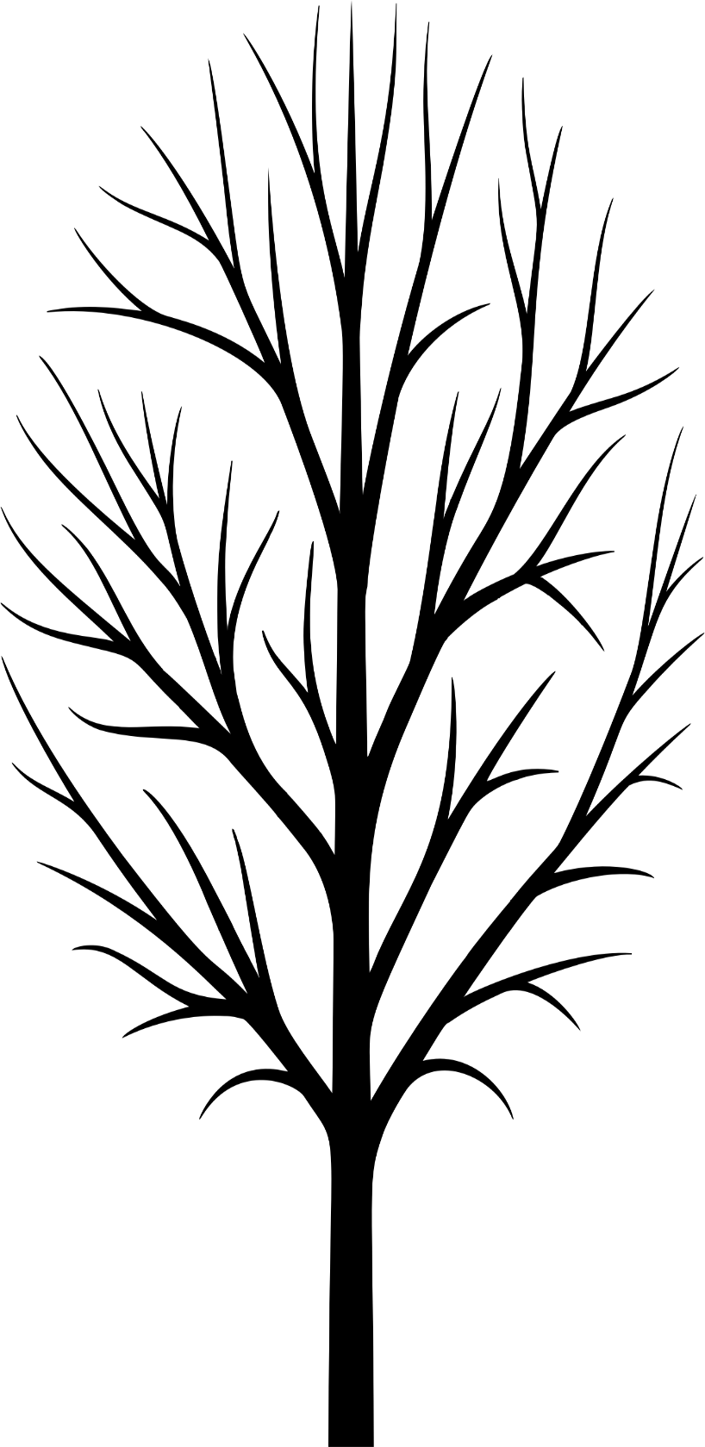

**Please note that most household cleaners are unhealthy and toxic to birds if exposed in a close proximity.**

**NO FEBREZE/GLADE PRODUCTS**

**TOXIC Foods**

|  |
| --- |
| Alcohol |
| Apple Seeds |
| Apricot Pits |
| Asparagus |
| Avocado |
| Butter |
| Caffeine |
| Cherry Pits |
| Chocolate |
| Dairy (in large quantities) |
| Dried Beans |
| Mushrooms |
| Nectarines Pits |
| Olives |
| Onions |
| Parsley |
| Peach Pits |
| Pears Pits |
| Plum Pits |
| Raw Peanuts |
| Rhubarb |
| Tomato |

**TOXIC Woods**

|  |
| --- |
| Alder |
| Apricot |
| Avocado |
| Buckthorn |
| Burdock |
| Camel Bush |
| Cedar |
| Cherry |
| Common Sage |
| Coriander |
| Elderberry |
| Foxglove |
| Heaths |
| Hemlock |
| Huckleberry |
| Jasmine |
| Juniper |
| Lupine |
| Mango |
| Myrtle |
| Nutmeg |
| Oak |
| Mistletoe |
| Orange |
| Pear |
| Red Maple |
| Red Sage |
| Redwood |
| Rhododendron |
| Rhubarb |
| Sumac |
| Tobacco |
| Tomato |
| White Cedar |
| Witch Hazel |
| Wisteria |
| Yew |